[**REGex Software Services**](https://www.linkedin.com/company/regexsoftware?trk=public_post_share-update_update-text)

Java Full Stack Development Program

Registration I'd:  **IIPRSS1404**

Name: **Shanmukh Subhash Kumbhar**

College Name: Dr. D. Y. Patil School of Engineering And Technology, Pune.

Subject: Assignment No.5 # Calculator

**Core Java Session 5 Assignments**

1. Accept the year and find whether the given year is Leap year or not.

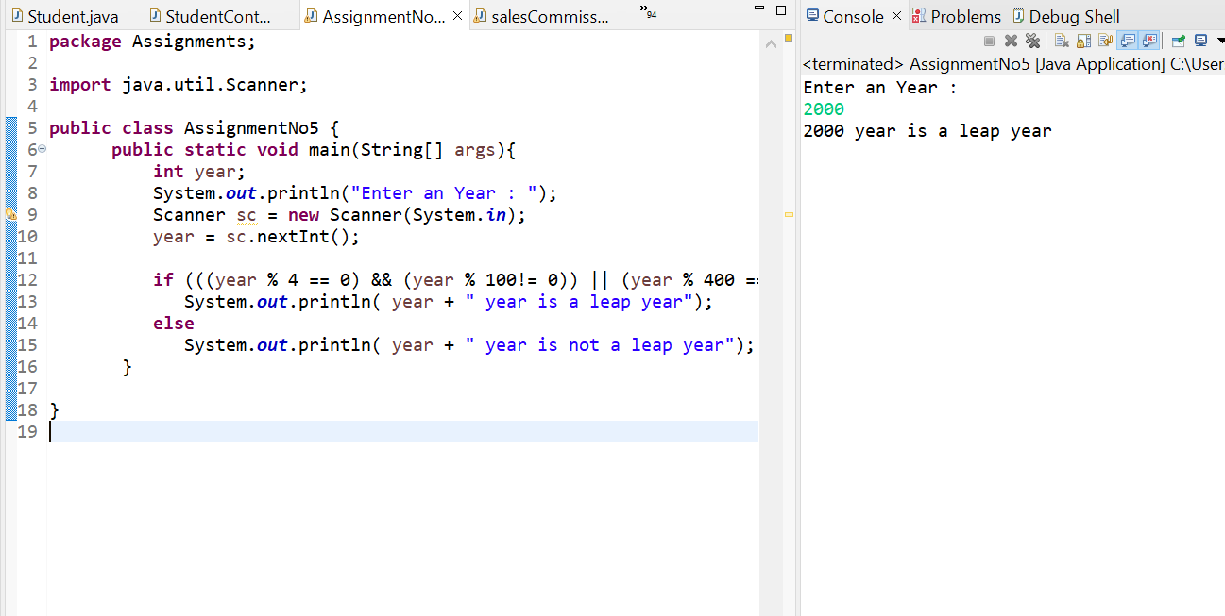

1. Accept Age from the console and find whether a person is eligible to vote or not.

3. Develop Sales Commission App

Calculate commission based on the following criteria

Sales Commission

-------- ---------

0- 10000 0%

10001-20000 10%

20001-30000 20%

30001 - rest 25%

Print Sales amount, Comm, and total

1. Develop a menu-based Calculator App with operations like ADD, SUB, MUL, and DIV using do-while.

